Accessible Information Standard Policy

The Groves Medical Group
Accessible Information Policy
Introduction
The Accessible Information Standard (AIS) came into effect on the 1st August 2016. All organisations that provide NHS care and/or publicly-funded adult social care are legally required to follow the AIS. The Standard sets out a specific, consistent approach to identifying, recording, flagging, sharing, and meeting the information and communication support needs of patients, service users, carers and parents with a disability, impairment or sensory loss. It is a law that aims to make sure people with a disability or sensory loss are given information that they can understand and the communication support they need.
The policy applies to all employees and partners, and also applies to other people who work at The Groves Medical Group practices including self-employed staff, temporary staff, and contractors.
Definitions
Accessible Information: Information which is able to be read or received and understood by the individual or group for which it is intended.
Communication Support: Support which is needed to enable effective, accurate dialogue between a professional and a service user to take place.
This includes accessible information and communication support to enable individuals to:
- Make decisions about their health and wellbeing and about their care and treatment;
- Self-manage conditions;
- Access services appropriately and independently; and
- Make choices about treatments and procedures including the provision or withholding of consent.
Application of the Accessible Information Standard
All providers of NHS care are required to meet the AIS. The Standard applies to all services users who have information or communication needs as a result of disability, impairment or sensory loss. This includes patients who are:
- Deaf;
- Blind;
- Deafblind; and
- Suffering from learning disabilities.
The standard can also be used to support people with:
- Autism;
- Mental health conditions; and
- Asphsia.
The AIS is also applicable to parents and carers.
Five Steps of AIS
There are five steps which The Groves Medical Group must take to ensure that the AIS is met. Each step is shown below:
- Identify: How does the service assess for disability related information or communication needs? How does the service find out if people have any of these needs? How does the service plan how it will meet those needs?
- Record: How does the service record those identified needs clearly? What systems are in place as part of the assessment and care planning process?
- Flag: How does the service highlight or flag people’s information and communication needs in their records? This could be in paper or electronic form. The chosen method must make it possible for all staff to quickly and easily be aware of (and work to meet) those needs.
- Share: Services sometimes need to share details of people’s information and communication needs with other health and social care services. This means that other services can also respond to the person’s information and communication needs.
- Meet: How does the service make sure that it meets people’s needs? How does the service make sure that people receive information which they can access and understand? How does the service arrange communication support if people need it?
Required Actions to Meet Each Step
- Identification of needs: The practice is consistent in its approach to the identification of patients, service users, carers and their information and communication needs, pertaining to disabilities, impairments and sensory loss.
- Recording of needs: The Group must ensure consistency when recording the needs of patients, service users, and carers which relate to a disability, impairment, or sensory loss. The Groves Medical Group will ensure that all needs are recorded accurately, read coded, and visible to staff enabling them to appropriately engage with the patient, their carer of family member(s).
- Flagging: The Group will make use of alerts on Emis clinical system, thereby indicating that an individual has an information or communication need. This shall enable staff to take the appropriate actions and ensuring that the needs of the patient are met.
- Sharing: The Group will ensure that data about patient information or communication needs is shared appropriately, in line with extant guidance and as part of the referral and handover process.
- Meeting: The Group will take the necessary steps to ensure that patients with communication or information needs receive information in a format which is accessible to them and in a manner in which they understand.
How The Groves Medical Group will meet the Accessible Information Standard
Identification: All staff will make appropriate arrangements for individuals to discuss their communication needs privately, should they wish to do so, whilst ensuring that sufficient information is ascertained and recorded accurately.
Recording and Flagging: The Group will ensure that the necessary read-coding of communication needs is added to the clinical records of patients upon registration. They will also ensure that the appropriate on-screen alert is operating and that it includes information regarding the preferred communication channel or what level of communication support is needed.
Sharing: Clinical members of staff are responsible for ensuring that, when a patient is referred to any other NHS or Social Care organisation, they are asked (at the time of consultation) for permission to share their communication needs with the other organisation.
All staff are to ensure they are aware of the applicable practice Privacy Notice for their region of England, Scotland, Wales, or Northern Ireland and should, if necessary, refer patients to this notice.
Consent must be obtained and is to be clearly identifiable and separate from other comments entered into the healthcare record. For further information, refer to the practice GDPR Guide and Consent Policy.
Meeting Patient Needs: The Group will ensure that all patients have the opportunity to have their individual communication needs met upon request. Posters will be displayed in waiting rooms to make patients aware of the services we can provide (see Appendix A).
The practice will ensure that a “hearing loop” is available throughout the premises or that a portable loop is available.
The practice will also ensure that the current contact details for access to properly qualified persons who are registered interpreters for deafblind persons or who use sign language and other assisted communication methods are available in reception. The practice will ensure that only persons who are registered interpreters, properly qualified, insured and DBS checked to Enhanced Disclosure level are used.
Registration
The Groves Medical Group will ensure that as much information about patients’ specific needs is captured during the registration process.
Resources
- Accessible Information Standard

Appendices
Appendix A: Poster
See overleaf.

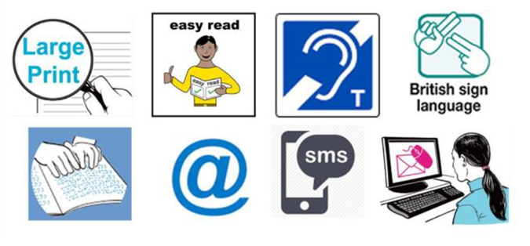
ACCESSIBLE INFORMATION STANDARD
The Accessible Information Standard aims to make sure that people who have a disability, impairment or sensory loss are given information they can easily read or understand.
Please inform practice staff if you have any communication support needs.
You need to help us make sure we get things right for you by recording your accessibility requirements and information needs alongside your other details.

