Welcome to Eastwood Primary Care Centre
PLEASE COMPLETE IN FULL AND RETURN THIS FORM WITH YOUR REGISTRATION

Registration pack  PATIENT NAME : | Please tick when enclosed.
GMS1 Form (Please Complete and Return)
Please include NHS number if known. The form must be signed.
Questionnaire (Both sides must be completed and returned)
SCR/EDSM Consent form (signed and dated)
Online access form (if applicable)
Third Party sharing consent form & other consent / wishes
NEW PATIENT QUESTIONNAIRE
PRACTICE USE
Forms checked & ID verified by:
Date
Appointments made if any:

If you have name, address and photo ID please bring to the surgery to show the receptionist for verification. However, if you do not have ID, we will still be able to register you.

PATIENT QUESTIONNAIRE - PERSONAL DETAILS
NHS Number if known…………………………….
Mr/Mrs/Ms/Miss: ________________(Surname) Maiden Name: ________________________________
First Name: _______________________ Date Of Birth: __________________ Sex (M/F) ______________
Address: __________________________________________________________________________________
_____________________________________________________ Postcode_____________________________
Telephone (Home/ mobile ): ___________________ email : ___________________________________
Who is your Next Of Kin? Name________________________ Relationship: ___________________________
Their Address: ______________________________________________________________________________
_______________________________________ Their Telephone number: ____________________________

Marital Status: Single/ Married/ Divorced/ Separated/ Widowed/ Living with partner
Ethnic background: (this is useful information as certain ethnic groups are prone to particular conditions):
Chinese
Mixed (please specify)
Other (please specify)
Black African
Indian
Pakistani

White British
White (Other – please specify)
Black Caribbean

Main Spoken Language: Do you require an interpreter? YES / NO
Are you an Asylum seeker? Date came 1st to UK
Lifestyle:
Smoking: Alcohol: Exercise:
Never Smoked
Current Non-smoker
Trivial < 1 cigarette/day
Light 1-9 cigarettes/day
Moderate 10-19 cigarettes/day
Heavy 20-39 cigarettes/ day
Very Heavy >40 cigarettes/day

Minutes per week
Tee Total
Trivial, 1 unit/ day
Light 1-2 units/day
Moderate 3-6 units/day
Heavy 7-9 units/day
Very Heavy > 9 units day

Allergies:
Are you allergic or sensitive to any medicines, food, animals, etc? Yes No

Admissions:
Please list any hospital admissions, operations and accidents with approximate dates:

Additional information we may find useful: (e.g. housebound/ special needs etc)

Current Medical History:
Do you suffer from any of the following?
Current Past
Current Past
Current Past
Heart attack
COPD
Dementia
Other (Please List)
Diabetes
Thyroid
Cancer
Depression
Glaucoma
Heart Disease
Angina
High Blood Pressure
Stroke/Mini Stroke
Asthma

Current Medication:
List any medication you are currently taking.

Family Medical History
 | Parents | Grandparents | Additional Information
Asthma
COPD
Diabetes
High Blood Pressure
Heart condition
Stroke
Cancer
Dementia
Depression
Glaucoma
Thyroid
Please state any other medical conditions

Do you have a disability, impairment or sensory loss? Yes No
If yes, do you require information or communication in an alternative (non – standard) format?
E.g. Large print, braille, electronic or audio? ______________________________________________
Women Only:
Do you use any form of contraception? YES/ NO If yes, please give details ____________________________
Date of last smear:______________________________
Have you had any previous abnormal smears? YES/NO If yes, please give details _______________________
__________________________________________________________________________________________
Have you had any pregnancies/ miscarriages? YES/ NO If yes, please give details_______________________
__________________________________________________________________________________________

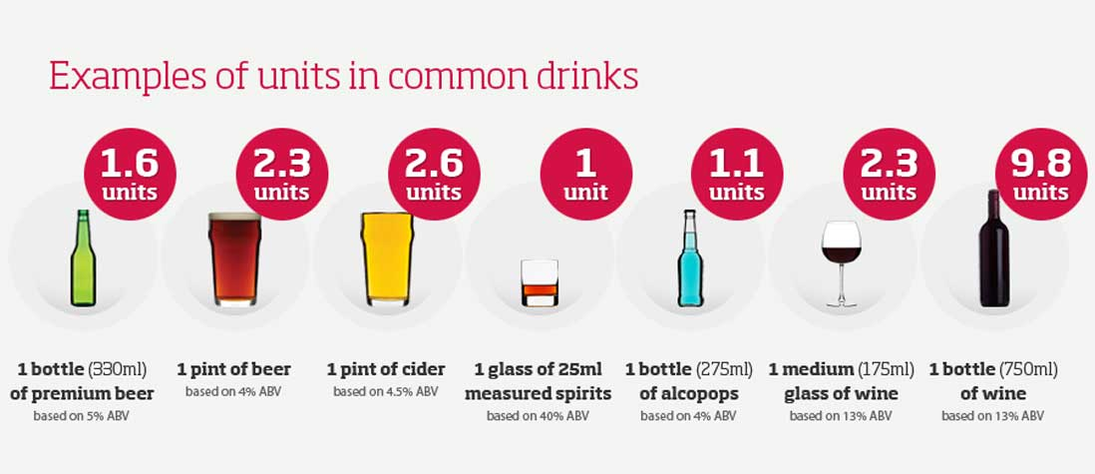
Fast Alcohol Screening Test (FAST)

Questions | Scoring System |  |  |  |  |  | Your Score
 | 0 | 1 | 2 | 3 |  | 4
How often do you have 8 (men) 6 (women) or more drinks on one occasion? | Never | Less than monthly | Monthly | Weekly |  | Daily or almost daily
Only answer the following questions if your answer above is monthly or less
How often in the last year have you not been able to remember what happened when drinking the night before? | Never | Less than monthly | Monthly |  | Weekly | Daily or almost daily
How often in the last year have you failed to do what was expected of you because of drinking? | Never | Less than monthly | Monthly |  | Weekly | Daily or almost daily
Have a relative/friend/  doctor/health worker been concerned about your drinking or advised you to cut down? | No |  | Yes, but not in the last year |  |  | Yes during the last year

Scoring: A total of 3+ indicates hazardous or harmful drinking

Men: | When was the last time you had more than 8 drinks in one day?
Women: | When was the last time you had more than 6 drinks in one day?
Select one: | Never | Over 12 months | 3-12 months | Within 3 months

Resuscitation Wishes and Power of Attorney
Do you have a DNACPR (Do not attempt Cardiopulmonary Resuscitation) form in place? | YES | NO
If Yes: Please provide details of who is aware of this and where it is retained. Please provide a copy for your records.
Does anybody hold Lasting Power of Attorney for Health and Welfare for you? | YES | NO
If Yes: Please provide details of who is aware of this and where it is retained. Please provide a copy for your records.

Service Families and Military Veterans
As a practice, we fully support the Armed Forces Covenant. We can only do this if we know our patients connections to the Armed Forces. Please tick the below boxes that apply to you:

HAVE YOU ever served in the British Armed Forces? | ☐ | I AM currently serving in the Reserve Forces | ☐
I AM married/civil partnership to a serving member of the Regular/Reserve Armed Forces | ☐ | I AM married/civil partnership to a Military Veteran | ☐
I AM under 18 and my parent(s) are serving member(s) of the armed forces. | ☐ | I AM under 18 and my parent(s) are veteran(s) of the armed forces. | ☐

Carer Information:
Please Circle your answer below if any of the following apply to you
Do you look after someone (unpaid). This could be a friend, relative or neighbour who due to illness, disability, frailty, poor mental health or substance misuse would struggle without your support?
Who do you care for? | Husband / wife / son / daughter / partner / friend / other
What is the primary condition / illness of the person you care for?
Does someone provide care (unpaid) for you?
I am cared for by | Husband / wife / son / daughter / partner / friend / other
I no longer wish to be on the carers register | Yes / No

Accessible Information:
Please Circle your answer below
Do you have any information or communication needs or have any learning disabilities? | YES | NO
If YES, how can we help to meet your needs:  Are you blind or partially sighted? | YES | NO
Do you have significant problems with your hearing? | YES | NO
Do you have significant mobility issues? | YES | NO
If yes, are you housebound? | YES | NO
Do you consent to share your information & communication needs with other providers of NHS and Social Care? | YES | NO

Eastwood Primary Care Centre
Application for online access to Appointments & Repeat Prescriptions
Surname | Date of birth
First name
Address

Postcode

Email address
Telephone number | Mobile number
I wish to have access to the following online services (please tick all that apply):
1. Booking appointments | □
2. Requesting repeat prescriptions | □
I wish to access my medical record online and understand and agree with each statement (tick)
1. I will be responsible for the security of the information that I see or download | □
2. If I choose to share my information with anyone else, this is at my own risk | □
3. If I suspect that my account has been accessed by someone without my agreement, I will contact the practice as soon as possible | □
4. If I see information in my record that is not about me or is inaccurate, I will contact the practice as soon as possible |  □
5. If I think that I may come under pressure to give access to someone else unwillingly I will contact the practice as soon as possible.  Signature  Date |  □

For practice use only
Patient NHS number |  |  | Practice computer ID number
Identity verified by (initials) | Date |  | Method  Vouching □  Vouching with information in record □  Photo ID and proof of residence □
Authorised by |  |  |  | Date
Date account created
Date passphrase sent
Level of record access enabled  Detailed coded record □  Limited parts □ |  | Notes / explanation
Sharing your GP record with Other Care Services who look after you

How you can help
You might think that your GP’s information system automatically “talks” to other services who might be involved in your care, like the hospital, outpatient clinic or community nurse, but this is currently not the case. In order to improve your care, we are trying to join up communication between different parts of the health and social care service but need your permission to do so.
How it benefits you
We would like any other service that ”talks” to your GP’s system (SystmOne) to have access to your GP record. This helps it to make better informed decisions about your health care, whilst also saving time, reducing duplication and the likelihood of mistakes. These services include:
- Hospital and outpatient clinics, including those in the community.
- Emergency and urgent care services, eg Emergency Department and out-of-hours GP services
- The ambulance service, East Midlands Ambulance Service.
- The community care teams, including community nurses and matrons, physiotherapists, occupational therapists, podiatrists and specialist nurses.
- Child health services, such as health visitors, school nurses.
- Social care services.
- Mental health services, such as counsellors, psychiatrists and community psychiatric nurses.
- Other GP surgeries, who you may choose to see outside working hours, eg in the evening or at weekends.

So which records do you want to share?
We want to share your ENTIRE GP record which includes all your past medical history, medications, allergies, vaccinations and so forth.
Who can see my shared record?
Only those people involved in caring for you and only those you have granted permission have access to your record. Your record will not be shared to any other party without your permission. They all have a duty to keep your record confidential, unless there is a lawful reason to break it.
Can I change my mind?
Yes you can, although bear in mind that another service will no longer be able to rely on using your shared record to look after you. It is also not always possible to separate out a shared record at a later date if you change your mind.
How do I give my consent?
Complete and sign the details below and return it signed and completed to reception at the surgery.
If, however, you have any doubts or questions, feel free to bring this form to discuss with your GP.

I would* / would not* like the information recorded at EPCC to be available to be seen by other care teams who are involved in my care where I have granted those care teams access to see it.
I would* / would not* like the information recorded by other care teams involved in my care to be seen by teams at EPCC where I have granted those care teams the right to add it.
*Delete as appropriate

Signed: ………………………………………………...Date: ………………………………………
………………………………………………………….Date of Birth: ………………………………….

OR

Patient Representative:……………………………….…….. Relationship to patient:……………………….………………..
National Record Sharing Service: Summary Care Record (SCR)
The National Record Sharing Service using the SCR makes it possible to share your medical information with services that care for you outside of Nottinghamshire. More information can be found via https://digital.nhs.uk/services/summary-care-records-scr
Summary Care Record (SCR): A Summary Care Record allows you to share information about medication, allergies and adverse reactions and further medical information that includes:
- Your significant illnesses and health problems,
- Operations and vaccinations you have had in the past,
- How you would like to be treated (such as where you would prefer to receive care),
- What support you might need and who should be contacted for more information about you.
Consent for Summary Care Record
Enhanced SCR: I understand that my ‘Summary Care Record’ contains key information about medicines, allergies and any bad reactions I have suffered, along with additional information regarding long term health conditions, relevant medical history, immunisations and health care and personal preferences. I realise that this will be available for authorised healthcare staff to view, after seeking my permission.
Yes, I would like an Enhanced Summary Care Record.
No, I do not want an Enhanced Summary Care Record.

General SCR: I understand that my ‘Summary Care Record’ contains key information about medicines, allergies and any bad reactions I have suffered. I realise that this will be available for authorised healthcare staff to view, after seeking my permission.
Yes, I would like a Summary Care Record.
No, I do not want a Summary Care Record
Name
Date of Birth
Representative Name (if under 16)
Signature |  | Date:
Data Sharing for Secondary Use
This means data is extracted from the GP surgery for use in research or planning; for example, to see who would need to shield against COVID19.
Your data will be shared UNLESS you specifically tell us otherwise. You will need to complete a TYPE 1 OPT OUT form, available here https://digital.nhs.uk/data-and-information/data-collections-and-data-sets/data-collections/general-practice-data-for-planning-and-research/transparency-notice#opting-out-of-nhs-digital-collecting-your-data-type-1-opt-out- or by registering your dissent online at https://www.nhs.uk/your-nhs-data-matters/
Consent to share information with a specified Third Party (relative or representative)

Patient Full Name :

Address:

Telephone Number:

I consent for the surgery to communicate to the person(s) named below, either in written form or verbally regarding any information connected to my health care whilst I am a registered patient at Eastwood Primary Care Centre.

Named Person (Third party):

Named Persons Address:

Named Persons Telephone Number:

Relationship to Patient:

Power of Attorney for Health held : Yes/No

Copy of Power of Attorney Attached: Yes/No

Signature:

Date:

