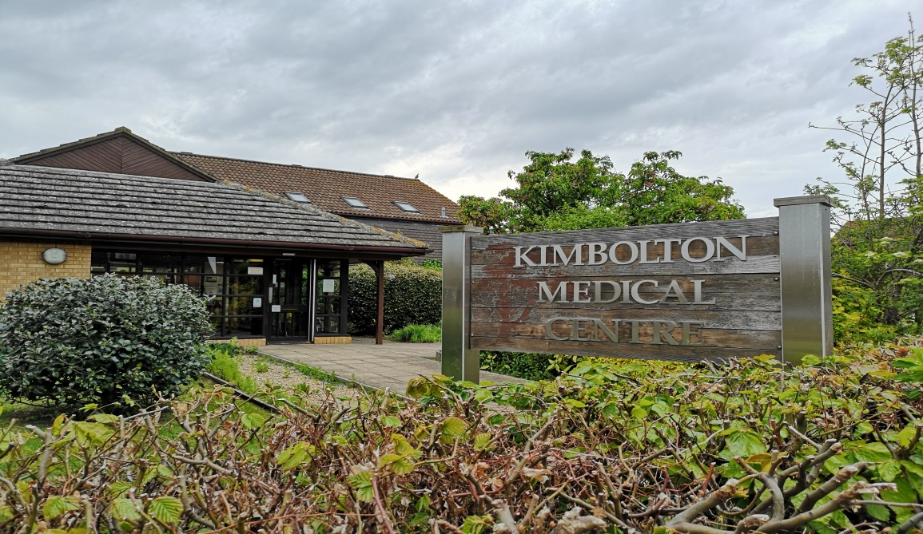

KIMBOLTON MEDICAL CENTRE
COMPLAINTS PROCEDURE

Kimbolton Medical Centre
Complaints Procedure

If you have a complaint or concern about the service you have received from the doctors or any of the staff working in this practice, please let us know. We operate a practice complaints procedure as part of a NHS system for dealing with complaints. Our complaints arrangements comply with the national regulatory framework.

How to complain
We hope that most problems can be sorted out easily and quickly, often at the time they arise and directly with the person concerned. If your problem cannot be resolved in this way or you wish to make a complaint, we would like you to let us know as soon as possible. Ideally this would be within a matter of days or at most a few weeks, as this will enable us to establish what happened more easily. If it is not possible to do this, please provide us with details of your complaint:
• Within 12 months of the incident that is the cause of the problem; or
• Within 12 months of discovering that you have a problem, if you had
good reason for not making the complaint at an earlier time.

Complaining on behalf of someone else
Please note that we keep strictly to the rules of patient medical confidentiality. If you are complaining on behalf of someone else, we have to be assured that you have his or her permission to do so. A note signed by the patient concerned will be needed, unless they are incapable (because of illness or mental capacity) of providing this.

What you should do
Complaints should be addressed to:
Mrs Nikki Yeoman, Practice Manager, Kimbolton Medical Centre, Hunters Way, Kimbolton, Cambs PE28 0JF. Telephone 01480 860205 or email hhcdata.huntersway@nhs.net
Alternatively, you may ask for an appointment with Mrs Nikki Yeoman in order to discuss your concerns. She will explain the complaints procedure to you and will make sure your concerns are dealt with promptly. It will be a great help if you are as specific as possible about your complaint.
Our commitment to you
We will acknowledge your complaint within three working days and aim to have looked into your complaint within 20 working days of the date when you raised it with us. We will then be in a position to offer you an explanation, or a meeting with the people involved. When we look into your complaint, we aim to:
· Find out what happened and what went wrong
· Make it possible for you to discuss the problem with
those concerned if this is your wish
· Ensure the complaint is resolved appropriately
· Make sure you receive an apology, where this is appropriate
· Identify what needs to be done to ensure the problem does
not arise again.

Our principles are
· To be patient focussed
· To be open and accountable
· To act fairly and proportionately
· To put things right
· To seek continuous improvement
If your complaint is not resolved by the Practice to
your satisfaction you can contact the Parliamentary
and Health Service Ombudsman.
Contact details are www.ombudsman.org.uk
Tel No: 03450154033
Help and information
For information and help in making a complaint you
can contact POhWER who are an Independent
Complaints Advocacy Service (ICAS)
Email: pohwer@pohwer.net
Tel: 0300 456 2370,
Postal address: POhWER, PO Box 14043
Birmingham B6 9BL

Contacting NHS England
We hope that, if you have a problem, you will use our practice complaints procedure to ensure it is resolved. We believe this will give us the best chance of putting right whatever has gone wrong and an opportunity to improve our practice.
However this does not affect your right to contact NHS England if you feel you cannot raise your complaint with us.
In this instance you should contact:
NHS ENGLAND, PO BOX 16738
REDDITCH, B97 9PT (For the attention of the complaints team).
Tel: 0300 311 2233
Email: england.contactus@nhs.net

