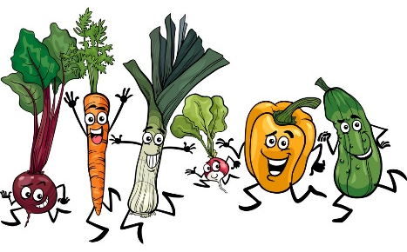
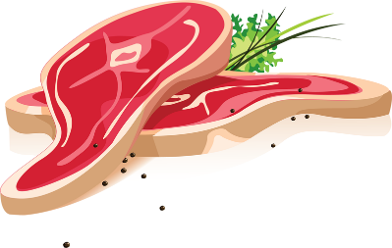
Food Health and Sustainability
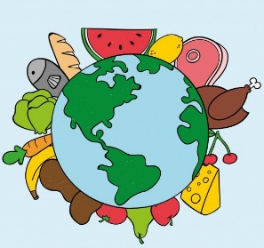
Food and the environment
Did you know that up to 30% of GHG emissions globally are linked to agriculture and food production, with an estimated 8–10% of manmade GHG emissions coming from food waste alone? The impact of the food we eat on the environment is one of the key changes we can make to tackle climate change. Our food system is also responsible for issues such as habitat loss, soil degradation, water usage and waste, all of which damage our environment. This is the reason that a lot of people are choosing to eat a lot more plant-based food. It is a great way to look after your health and the planet. Please see the following link for more information: https://wrap.org.uk/taking-action/food-drink/actions/action-on-food-waste#
Red meat such as beef, lamb and pork are a good source of protein, vitamins, and minerals. But eating a lot of red and processed meat also increases your risk of bowel (colorectal) cancer. It is recommended that people who eat more than 90g (cooked weight) of red and processed meat a day cut down to 70g or less. Please see the link for more information on meat in your diet: https://www.nhs.uk/live-well/eat-well/meat-nutrition/
How you can help
Lowering your meat consumption
- Meatless Mondays is an international campaign encouraging people to eat completely meat free food for just one day of the week please see the following link for more details: https://meatfreemondays.com/
- You can find alternatives to meat and dairy at the following link: https://www.bda.uk.com/uploads/assets/89de0ac6-5141-4258-9c34ff71566821ef/One-Blue-Dot-Meal-swaps.pdf
Food wastage
Did you know that:
- An estimated 7.2 million tonnes per year of food and drink waste is generated by UK households.
- 19% of food and drink of one home ends up as kitchen waste.
- The average UK household produces 270 kg of food waste a year, or 5 kg per week.
How you can help
Managing the food, you buy
- Buy little and often
- Use set weekly meal plans so you will only buy what you need
- Try not to stock up on perishable goods.
- Don’t shop on an empty stomach as you can be tempted to buy more than you need!
- Reuse leftovers where possible in future meals.
- Consider using frozen fruit and vegetables – you can buy in bulk and only use what you need.
- Use leftover vegetables, fruit, and peelings to make your own compost if you can. See the link for details: https://www.edenproject.com/learn/eden-at-home/how-to-make-a-compost-heap-10-top-tips
- Grow your own fruit and vegetables if possible. They will be fresh, and you can pick as you need.
- Rotate your food stocks using older foods first and place newer stocks at the back.

