
HAPPY HOUSE SURGERY
Durham Road, Sunderland SR3 4BY
Tel 0191 528 2222
Fax 0191 528 2626

ACCESS TO INFORMATION AND RECORDS
We take patient confidentiality very seriously however we appreciate that, for some patients, it is useful for them to nominate a representative who has some access to your information.
We have two levels of access which you can authorise: basic and advanced

LEVEL 1 - BASIC ACCESS
This access is ideal to give spouses / partners and parents who call on behalf of their adult children and allow them to do the following on your behalf:
- Book / check / alter appointments
- Request a repeat prescription.
- Check if a prescription is ready, what has been prescribed and collect it on their behalf
- Check if a test result is back BUT NOT WHAT THE RESULT IS.
This level does not allow the surgery to share information in regards to any medical conditions
LEVEL 2 – ENHANCED ACCESS
This access is ideal for patients who have carers who support their day to day lives and gives access to all areas of your information. We would expect the representative to be able to speak on your behalf and for the surgery to liaise with them where necessary.
Please let us know if your representative is also your carer so we can make a note of it. We can often offer additional support and advice to carers.
STOPPING ACCESS
If you wish to change or stop the access your representative has you must complete an ACCESS REMOVAL FORM – please remember it is your responsibility to stop or change access rites and the surgery will not remind you to review any access arrangements you have made.
ACCESS TO INFORMATION AND RECORDS – APPLICATION FORM
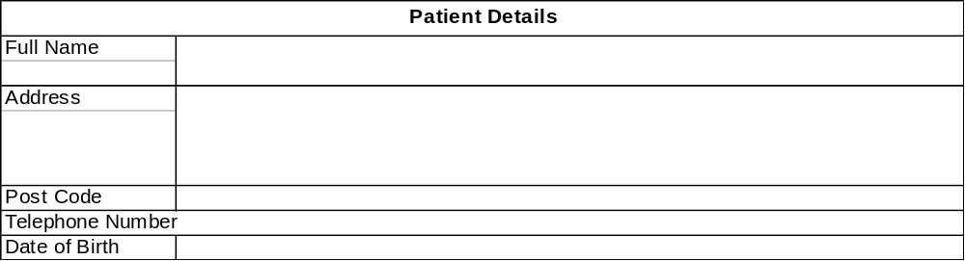

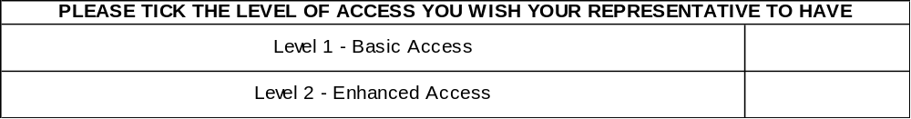

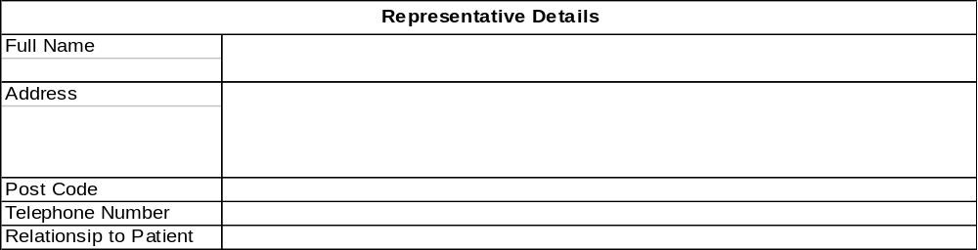
I agree that the person signed below is able to have the access to information held by Happy House Surgery as indicated above.
Patient Signature: …………………………………………………………. Date: ………………
Representative Signature: ………………………………………………….. Date: ……………….
By signing this form you are consenting to your details being kept by Happy House Surgery
Happy House Surgery accepts no responsibility for false information given by any of the above persons

