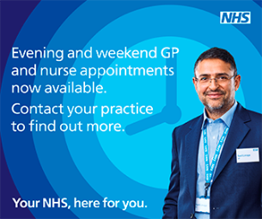
Improved Access to GP Appointments
A new and improved service to access GP appointments launched in Buckinghamshire on 1 October and is available to all patients registered with a Bucks GP. This service involves local GP practices working together to offer patients better access to appointments. It means that you can now book an appointment in a practice local to you:

· Up until 8pm from Monday to Friday
· Selected hours on a Saturday
· 9am until 1pm on Sunday and Bank Holidays (at one of the three Improved Access Hubs located across the county)
Dr Rebecca Mallard-Smith, Clinical Director of Community Urgent Care, said: “This new service is an example of how we can all work together to improve care for our patients. For us to launch this new service, all GP practices have been working closely together to ensure that appointments are available between 8am and 8pm including other local surgeries to your normal surgery. This should mean that patients also have greater flexibility for routine, bookable appointments. Patients can receive the care they need, closer to home, at an agreed time preventing the need to use urgent care facilities for GP care. It is, however, not a walk-in service and if you need urgent medical advice after 6.30pm or at a weekend please phone NHS 111 in the first instance who will be able to advise you and book an appointment if necessary.”
Various practices will be offering this ‘improved access’ service up until 8pm from Monday to Friday, and on selected hours on a Saturday (please see the list below, although your registered practice can confirm which practice your appointment will be at, as these days may change).
The following practices will offer appointments as part of the ‘Improved Access’
Mondays Swan Surgery, North End, High Street, Buckingham, MK18 1NU
Tuesdays & Fridays
Alternating between Pitstone Surgery, Yardley Avenue, Pitstone, LU7 9BE
& Ashcroft Surgery, 34 Stewkley Rd, Wing, LU7 0NE
Wednesdays Wing Surgery, 46 Stewkley Road, Wing, LU7 0NE
Thursdays Norden House Surgery, Avenue Road, Winslow , Bucks, MK18 3DW
Saturdays Swan Surgery or Norden House Surgery
On Sundays and Bank Holiday weekends, additional appointments will be available from 9am until 1pm. These appointments can be booked through the practice you are registered with, and are being offered from three Improved Access Hubs located at:
- High Wycombe Hospital: (located at the MIIU) Queen Alexander Road, High Wycombe, HP11 2TT
- Stoke Mandeville Hospital: Corridor 5, Gate 2, Mandeville Road, Stoke Mandeville, HP21 8AL
- Threeways Surgery: Pennylets Green, Stoke Poges, Buckinghamshire, SL2 4AZ

