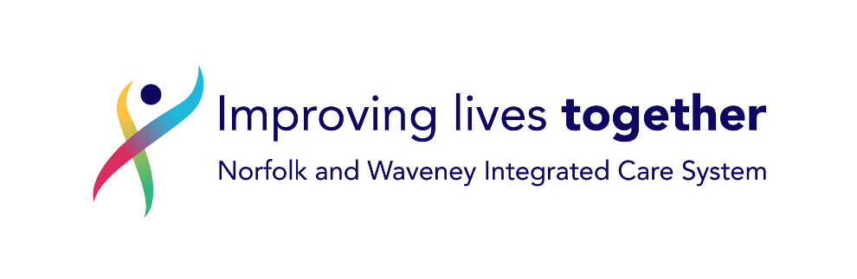

Norfolk and Waveney Integrated Care System - Privacy Notice for Secondary Use of Data
July 2022

Norfolk and Waveney Integrated Care System Privacy Notice for the Secondary Use of Data

Who we are?
We are Norfolk and Waveney Integrated Care System (ICS)

We are a group of local health and care organisations

We work together to improve the health of people living in Norfolk and Waveney.

Our partnership includes:

- East Coast Community Healthcare Community Interest Company
- Integrated Care 24 (IC24)
- James Paget University Hospitals NHS Foundation Trust
- NHS Norfolk and Waveney Clinical Commissioning Group
- Norfolk and Norwich University Hospitals NHS Foundation Trust
- Norfolk and Suffolk NHS Foundation Trust
- Norfolk Community Health and Care NHS Trust
- Norfolk County Council
- Queen Elizabeth Hospital King’s Lynn NHS Foundation Trust

What is the ‘secondary use of data’?

“Secondary Use” data is data that is not for your direct care, meaning it is not used as part of the care that doctors and nurses care give you.

Examples of secondary use data Population Health Management and Risk Stratification.

These projects will review data to find out if particular groups of patients, across the area, can be supported in some way.

This support might include buying new services or contacting particular patients with extra help, for example.

This use allows us to deliver the services that are needed, in the right areas, helping to support good health and social care.

Decisions will not be made without human involvement.

What is a Privacy Notice?

This Privacy Notice tells you about the data we collect and hold about you, what we do with it and how we look after it.

This notice talks about how this group of providers use the data.

If you want to find out about how a particular member of the group uses your data, you can visit their website.
A list of our members’ websites may be found here.

Our commitment to Data Protection and Confidentiality
Data protection law gives you certain rights;

To be told how your data is used
To make a complaint or say you don’t want your data to be used
To ask us to stop using or sharing your data
To ask us to correct your data if it is not correct

Norfolk and Waveney Health Care Partnership promise that your information will be:

- Used in a way that is lawful
- Restricted to only the health and social care data that our partner organisations hold about you
- Kept safe
- Accessed only by certain, authorised people
- Only be used to ensure better care and manage the local health and social care system

How will the NWHCP use your information?

NWHCP has developed a central storage for health and care data

It is called the Health and Care Data Architecture (HCDA)

The HCDA lets us combine data in a single secure location.

We can then pull data from each provider about how the patient used that service
For example, combining data about your hospital visits with data about your GP appointments

We do not create new information about you

The HCDA is based in the cloud and we use Microsoft to store the data

What personal data will we use?

- Basic information such as: name, address, phone number
- NHS number
- Medical conditions
- Treatment provided and contact the individual has had with the organisation
- Care plans

- Emergency department treatment
- Discharge summaries
- Medication reviews
- Physical and mental health reports
- Care and support plans, and reviews
- Social care records
- Results of investigations, such as x-rays, scans, and laboratory tests

Please note that this list is not everything, and the data may be different for each type of project or provider

How will we use your data?

Once we have pulled the data together into the HCDA, health and care teams can make a request to access it

Every request to use your data will require approval from an NWHCP governance body.

Where possible, we will remove any data that shows who you are or can be traced back to you as a patient. This is called ‘Anonymisation’.

If we can’t anonymise the data, we will remove your name but use a code instead so there is less risk that people using the data will know that you are the patient

In very special circumstances, we may use data that shows who you are. This is allowed in very specific times and has been approved by NHS authorities.

Your personal data will not be transferred outside of the UK.

How long do we keep personal data?
Your personal data is kept securely and according to the Records Management Code of Practice for Health and Social Care 2021.

National Data Opt-Out
The National Data Opt-Out was introduced on 25 May 2018, giving people the ability to opt out from the use of their data for research or planning purposes, in line with recommendations of the National Data Guardian in their Review of Data Security, Consent and Opt-Outs.

You can view or change your National Data Opt-Out choice at any time by using the online service at https://www.nhs.uk/your-nhs-data-matters/ or by clicking on ‘Your Health’ in the NHS App and selecting "Choose if data from your health records is shared for research and planning".

As your opt-out choice is recorded against your NHS Number, we can ensure that your choice is respected. The NWHCP will not use your data where you have shown that you do not want your data used for planning and research purposes.

Your information rights and further information
To find out more information about your information rights, please:

- Contact the Data Protection Officer for our member organisations. NWHCP.IGPeerGroup@nsft.nhs.uk
- Email the NWHCP Information Governance Service Team NWHCP.IGPeerGroup@nsft.nhs.uk
- To make a complaint about how we process your data, please contact us NWHCP.IGPeerGroup@nsft.nhs.uk. If you are unhappy with our response or how we have used your data, you can make a complaint to the ICO via:
- Contact the Information Commissioner’s Office
Wycliffe House, Water Lane, Wilmslow, Cheshire, SK9 5AF Tel: 01625 545 740 http://www.ico.gov.uk/

