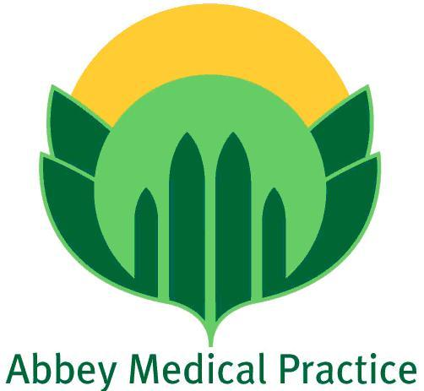

**Virtual Patient Participation Group (PPG) sign-up form**

If you are happy for us to contact you periodically by email please complete your details below and hand this form back to either reception or by post to: Abbey Medical Practice, 63 Monks Road, Lincoln, LN2 5HP

