ALLESLEY PARK
MEDICAL CENTRE

2 WHITAKER ROAD
ALLESLEY PARK
COVENTRY CV5 9JE

Tel: 024 7667 4123
Fax: 024 7671 8166
www.allesleyparkmedicalcentre.co.uk

DOCTORS

Dr Elizabeth Cowan (Female) MBChB, DRCOG, MRCGP, Manchester 1980
Dr Robert Jones (Male) MBBS, DRCOG, MRCGP, London 1987
Dr Daniele Thornton (Female) MBChB, MRCGP, Leeds 1988

Dr Gavin Shields (Male) MBChB, DCH, Birmingham 1989

Dr Mathew Butler (Male) MBBS, MRCGP, London T (GP) 1994
Dr Charlotte McCrone (Female) MBChB, MRCGP, DRCOG, DFSRH Birmingham 2010
Dr Helen Dyer (Female) MBBS, DCH, London 1988
Dr Jack Bambrough (Male) MBChB Warwick 2012

The Partners hold a current General Medical Services (GMS) contract with NHS England.

To register, please present at reception. If you are living within our practice boundary (see map on page 6) we will take your registration details. You will be registered with "The Practice" but can state a preference of a "usual" doctor. After registration you will be offered a health check appointment. All patients are allocated a named accountable GP. Please either ask at the time of registration or at your next visit to the surgery for the details. This will not affect your ability to book an appointment with any of the GP team.

This practice does not discriminate on the grounds of race, gender, social class, age, religion, sexual orientation, appearance, disability or medical condition.

Please let us know of any changes in your personal details as soon as possible e.g. married name, new address, telephone number etc.

NURSES
Jackie Carlson, Advanced Nurse Practitioner RGN, BSc Hons
Angela Tyrrell, Advanced Nurse Practitioner RGN, BSc Hons
Cindy Keegan, Advanced Nurse Practitioner, RGN, BSc (Hons), MSc
Debbie Stephenson, Practice Nurse RGN, RM
Jacqueline Wilson, Practice Nurse RGN
Kim Goudie, Health Care Assistant

The nurses offer a wide range of services including:
New patient health checks
Health promotion programmes

Asthma, Diabetes and Blood pressure care
Immunisation for foreign travel
Flu injections
Cervical smears
Phlebotomy (blood taking)
Menopause advice
Family planning advice
Ear syringing
Wound dressing and removal of stitches
Minor Injuries: includes cuts, bruises, sprains, burns and minor head injuries.
Yearly health checks for those over 75 years of age
ECG tests requested by the doctors
Triage(assessment of minor illnesses)
Chronic Heart Disease follow up
Child and Adult immunisation
(Please note if you are bringing children for any immunisation and you are not the parent you will need written consent from the child’s legal guardian)
Stop Smoking advice

Practice Manager & Business Manager
The Practice Manager, Kevin Arnold, is responsible for the administration of the Practice. He would be very happy to hear your views and suggestions about services offered by the Practice. Marie Luxmoore is our Business Manager and deals with the financial running of the practice.

Receptionists
Our team of receptionists are available to deal with making appointments, ordering repeat prescriptions and general queries during our opening hours. (please refer to our surgery hours)

If the receptionists are unable to deal with your queries they will pass them on to the appropriate Doctor or member of staff.

Administration Staff
Our administration team are able to deal with a number of queries including referrals, medicals reports and requests for copies of notes.

ATTACHED STAFF

District Nurses
A team of District Nurses, led by Debbie Hill, is attached to our surgery, based at Tile Hill. The team can be contacted on 0300 200 0011 between 8:30 am and 5:00 pm daily, Monday to Friday. Our Community Matron Nurse is Karen Thomas on the same number.

Health Visitor
We also have a Health Visiting Team attached to our surgery who are known geographically as the Coundon Team. They can be contacted on 0300 020 0099 between 8.30am – 5.00pm daily, Monday to Friday. Our allocated Health Visitor is Neil Barham.

Midwives
Lorna Coyle (RGN, RM) and a team of midwives are attached to our surgery. They share the responsibility, with the doctors, for antenatal and postnatal care. They are available at the surgery on Thursday and Friday between 1:00 pm and 4:00 pm, or via the hospital on 024 7653 8977 outside these hours.

Counsellor
Frances Averell (BAC accredited, UKCP registered) is our in-house counsellor. Referral to Frances is via a doctor. We also have an in house Mental Health Worker (IAPT) called Jessica O’Reilly and Nazia Parveen.

GP Registrars / Medical Students
The Practice is registered to train Health Care Professionals and you may be offered, with your permission, an appointment with a GP Registrar, or a medical student may be present at your consultation.

OTHER NHS SERVICES
Minor surgery - Cryotherapy

SURGERY HOURS
The surgery is open on a Monday between 7.00am and 7.30pm, Tuesday and Thursdays between 8.30am and 8.00pm, Wednesdays between 8:30 am and 7:30pm and Fridays between 8:30 am and 6:30pm. Surgeries operate throughout the day. From 7.00am to 8.30am and 6:30pm to 8:00pm the building is locked and only those with an appointment during that time will gain entry using the intercom. We do not deal with calls or any other business during these hours.

The building has suitable access facilities for disabled patients. All consulting rooms are on the ground floor.

(Please Note that surgery may be closed at times to allow for Staff meetings and training and for Protected Learning sessions for the doctors.)

ON LINE SERVICES
The practice currently offers the facility for patients
- To book, view, amend, cancel and print appointments on line
- To order on line, view and print a list of their repeat prescriptions for drugs, medicines or appliances
- To view online, export or print summary information from their record, relating to medications, allergies and adverse reactions
- To view online, export or print detailed coded information held in their own records wef 1st April 2016. A separate application form is required for this service.
- Please visit our website at www.allesleyparkmedicalcentre.co.uk ‘Do it Online’ section.

APPOINTMENTS
Each surgery consists of a mixture of appointments; some can be booked in advance (pre-bookable), and others, which are not released until the morning of that day. Morning surgeries also include telephone consultations, which are used when a visit to the surgery is not deemed necessary. A range of appointments can also be booked on-line by registering for our Patient Access service. This service also includes the ability to view summary information about medication and allergies.
Please visit our website www.allesleyparkmedicalcentre.co.uk to register for this service.

- Appointments can be made on – line via our website (registration required), by telephoning the practice on 02476 674123 (Option 2) or by calling in to the surgery. Please indicate what type of appointment you require.
- Surgeries are available each day Monday to Friday and we offer morning (From 7am on a Monday morning only), afternoon and early evening appointments.
- All patients that telephone on the day may be offered an appointment with our Nurse Practitioner who can deal with anything except for sick notes. The Nurse Practitioners are also fully qualified to issue prescriptions. Wherever possible we try to accommodate the patient with the doctor of their choice.
- Separate appointments systems operate for additional services such as minor surgery, liquid nitrogen clinics, child health surveillance, antenatal and postnatal consultations. You can book appointments in advance - this is normally around six weeks ahead for doctors and four weeks for nurses.

We are committed to giving the best possible service to our patients and ask that you:
- Arrange appointments for as far in advance as is appropriate
- Please help other patients by not requesting an urgent appointment for a problem that can wait a day or so
- If you cannot keep your appointment please let us know as soon as possible as it can always be used by someone else.
- Please report to reception on arrival for your appointment or use the automated check in screen.
- Every effort is made to try to get you seen by your doctor of choice; if you phone ‘on the day’ and your preferred doctor has no appointments you may be given an appointment with another doctor or Nurse Practitioner. If this is not suitable you may wish to visit Coventry Walk In Centre which is available until 10pm each day. We may also be able to offer you either a Doctor or Nurse appointment off site including weekends if this is more convenient. Please ask a receptionist for availability details.
- To assist the practice in keeping the appointment times, please book one appointment for one health issue you may have. This will enable the clinician to deal thoroughly with your problems.

HOME VISITS
Home visits can be made for patients who are too unwell to get to the surgery. Please try and telephone before 10:00 am wherever possible. Please remember several patients can be seen in surgery in the time it takes to do a home visit. The doctor also works more efficiently in the surgery, and has easy access to nursing help, emergency drugs, hospital communications and equipment that cannot be brought to your home.

SICK NOTES
The first seven days off work due to any illness are covered by a self-certificate available from your employer. You do not need to see a doctor until the eighth day of your illness. If a note is required before this a charge will be made, as this is a private service.

REPEAT PRESCRIPTIONS
Repeat prescriptions are issued at the doctor's discretion for patients on long-term treatment. Repeat prescriptions can be ordered via our website, www.allesleyparkmedicalcentre.co.uk by registering for our Patient Access service. Other methods of re-ordering include using the tear-off printout found on the right hand side of your last prescription. Just tick the appropriate boxes and return it to us. Please give exact drug names, doses and quantities when ordering and your computer reference number if known. Requests for prescriptions can also be made, by post, or calling in to the surgery during routine hours. Please allow two complete working days before collection and make allowances for weekends and holidays. If you are going on holiday and ordering earlier than you should be, please make a note of this on the bottom of the prescription.
The practice also provides an electronic prescription service (EPS).Prescriptions can be sent electronically to a pharmacy of your choosing. Please speak to your preferred pharmacy to register for this service or ask at the surgery for further details.

SPECIMEN COLLECTION
Specimens must be received at the Practice by 11:00am as usually collected at 11:30am Monday to Friday and delivered to the hospital. Results take at least two working days for blood tests, five days for infection screens, ten days for x-rays and up to six weeks for cervical smears. Please phone after 2:00 pm Monday to Friday for results. If a hospital doctor requested your test you should direct your enquiry to the hospital.

PRIVATE SERVICES

Medicals/Reports
Medical Reports requested by a solicitor or insurance company are not covered by the NHS and they therefore incur a private fee. The fee is dependent upon the service requested. It may be that the party requesting the information covers this fee, but from time to time the patient is liable to pay the fee. For an up to date quote please contact the surgery.

Please note that if you do not attend for a private appointment or cancel less than 24 hours before the appointment you will be charged a fee.

Letters/Passport signing
If you need a passport photo verified the NHS does not cover this. There are some types of letter and/or signing that we will not undertake and a list is available on request. Any letters or reports that are requested and completed but not collected, will still incur the designated fee.

CONFIDENTIALITY
The Practice is registered under The Data Protection Act 1998.

All doctors, nurses and staff are bound by a strict duty of confidentiality. Information may be shared with other healthcare professionals to provide you with the best informed care e.g. Midwife, District Nurse or Health Visitor. However no outside agency will be given any information from your records without your permission e.g. insurance companies or solicitors. No information will be given to partners or relatives without consent. You have the right to see your own records upon written request, both hand-written or from the computer (A fee may be payable for copies). For audit purposes it may be necessary to share data with NHS England (and their Area Teams (AT)) via the Health and Social Care Information Centre (HSCIC). Occasionally the HSCIC and AT requires access to patient notes to make sure we are fulfilling our contract with them in Chronic Disease Management and to support commissioning, public health planning and research. If you do not wish your notes accessed for this purpose please let us know.
Please visit our website www.allesleyparkmedicalcentre.co.uk to see the full details of our fair processing notice which explains why our practice collects information about you and how that information may be used and shared.

NHS Summary Care Records (SCR)

A SCR is an electronic summary containing limited patient information which can be shared to assist with your emergency care. The information contained within the SCR is: medication, allergies and adverse reactions. This information means that healthcare staff can provide you with safer care when your GP practice is closed or when you are away from home in another part of England. Only Healthcare staff who are directly involved in your care would be able to view your SCR.

Each patient has a choice regarding a SCR:
- You can choose to have a SCR: you do not need to do anything
- You can choose not to have a SCR: you need to let your GP practice know by filling in and returning an opt-out form
For further information regarding SCR:
- Phone the SCR information line on 0300 123 3020
- Contact your local Patient Advice and Liaison Service (PALS) www.pals.nhs.uk, or
- Visit www.nhscarerecords.nhs.uk

COMMENTS/COMPLAINTS/SUGGESTIONS
We endeavour to give you the best service possible at all times but there may be occasions when you wish to express dissatisfaction. We offer an informal, in-house procedure to deal with your concerns. The procedure does not deal with legal liability or compensation and does not affect your right to complain to Coventry & Rugby CCG or ICAS (Independent Complaints Advocacy Service 0845 51203748).

ICAS is a free independent, impartial, non-judgmental and confidential service for anyone needing help or advice regarding a complaint about NHS treatment. They collaborate closely with The Patient Advice & Liaison Service (PALS). Contact Healthwatch Coventry on 02476 252 011 or Email: info@healthwatchcoventry.co.uk

PALS provide confidential advice and support to patients, families and their carers. It also gives assistance in resolving problems and concerns quickly. Information about local health services is also available (02476 536 804)

If you wish to make a complaint please contact the Practice Management by telephone or in writing. An appointment to discuss the details will be made within seven days. You may bring a friend or relative with you to the meeting. Please note that due to our confidentiality protocol we need your written consent for a third party to complain on your behalf.

All patients can also complete a Friends and Family Test (FFT) survey form either on line, via our website, or when visiting the surgery in order to provide the practice with up to date feedback on the service that we provide.

CARERS
Do you have a carer, or do you care for someone else? Please let us know as we can offer help, advice and support.

WORKING TOGETHER
We endeavour to treat all patients with courtesy and respect and we expect the same good manners from our patients. We will not tolerate any form of abuse, whether its verbal or physical. Patients using any threatening or violent behaviour will be deducted from our list.

MINOR ILLNESSES
If you have minor illnesses such as coughs, colds, flu, sore throats etc. these are caused by viruses, which do not respond to antibiotics, and can be managed with simple painkillers. There are leaflets available in the reception area.

LOCATION
We are situated on the corner of Winsford Avenue and Whitaker Road in Allesley Park.
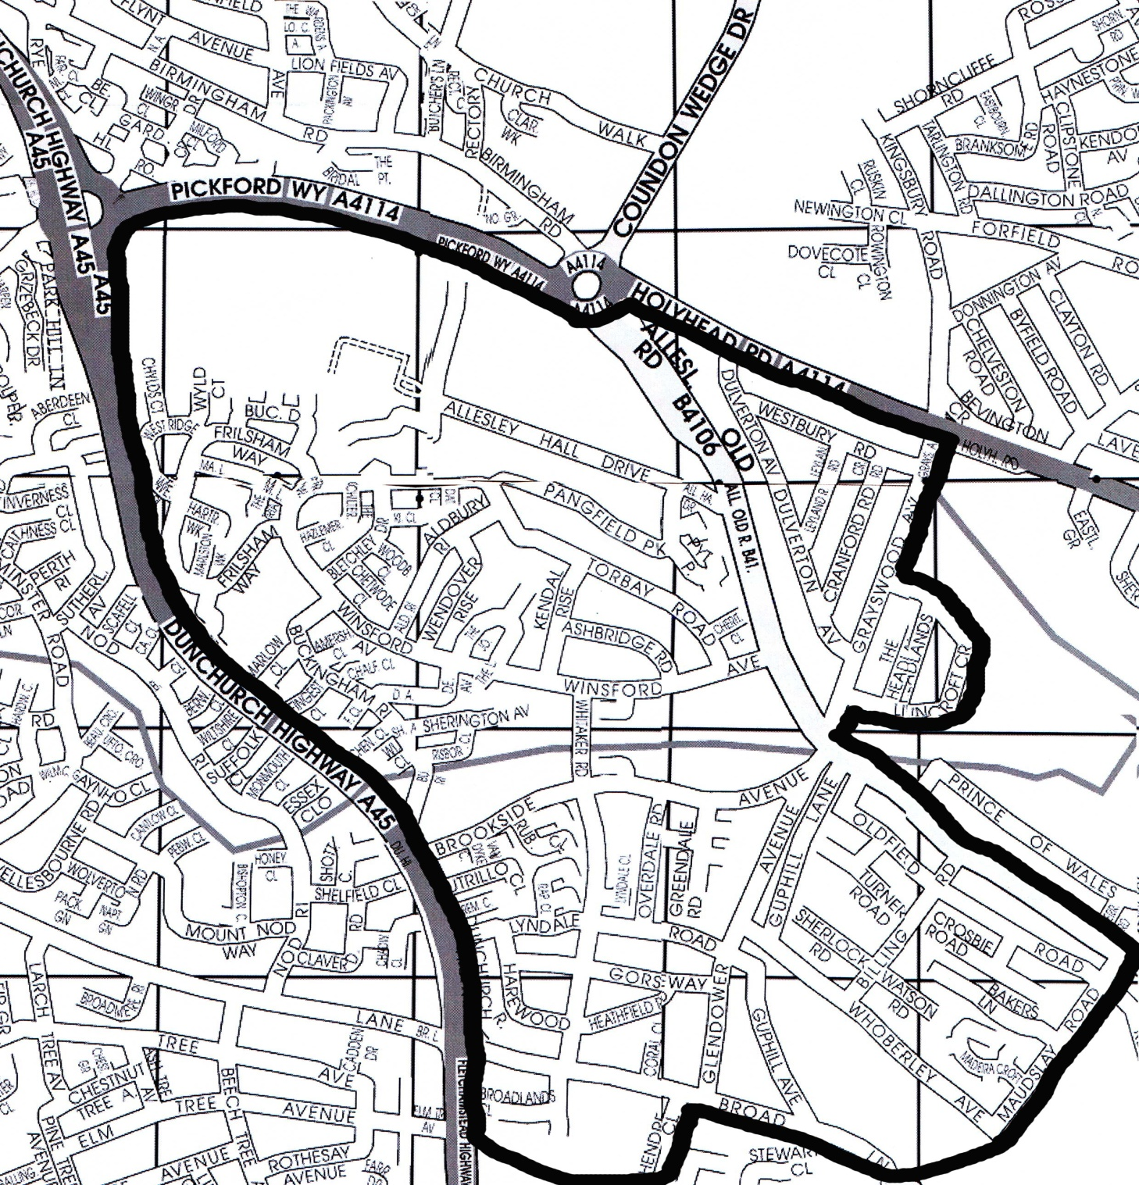

We accept new registrations from within the boundary as shown on the map by a black line.
If you change your address and move out the area, you will need to re-register with a doctor nearer your new home. This ruling is strictly adhered to, to make it fair to everyone.

Car Parking
There are designated disabled parking bays.
Community car parking is very limited in front of the surgery but there are parking spaces across the road. (2 hour return restrictions apply)

OUT OF HOURS SERVICES

FREEPHONE - NHS 111 (Dial 111 only from any phone)

This is a FREE National telephone advice line where a team of qualified staff will be able available to talk to you over the telephone. Available 24 hours per day all year round.
Emergency Out-of-Hours provision is the responsibility of NHS England Coventry and Warwickshire CCG. They have commissioned Warwickshire Ambulance Service to provide emergency care when the surgery is closed.

In an emergency call 999

OTHER ALTERNATIVE SERVICES

Patient Care and District Nursing Service - 0845 608 0275
Walk-In-Centre – 024 7624 6789 or 0300 2000 060
The walk In Centre can be found next to Coventry and Warwickshire Hospital, in a newly built building called City of Coventry Health Centre. It is for minor illness or injury or advice. It is open 8:00 am to 10:00 pm every day.

USEFUL TELEPHONE NUMBERS
Alcoholics Anonymous 024 7622 6619
British Pregnancy Advisory Service 024 7652 5433
Carers line 0345 573369
Childline 0800 1111
Citizens Advice Bureau 024 7622 7474
Coventry Benefits Advice Line 024 7683 2000
Coventry & Rugby CCG , Christchurch House 024 76552225
CRUSE (bereavement advice) 024 7667 0714
Greyfriars Lane, Coventry, CV1 2GQ 024 7655 2225
Healthwatch Coventry 024 76 252011
Health Service Ombudsman 0845 1054033
Help registering with a doctor 024 7624 6010
HIV Network 024 7662 9292
Hospital Appointment Enquiries 0800 252060
ICAS (Independent Complaints & Advocacy Service) 01273 229002
Interpreter services 024 7678 6878
PALS (Patient Advice & Liaison Services) 024 76 536804
Relate (relationship counselling) 024 7622 5863
Samaritans 024 7667 8678
Sexually transmitted disease - men 024 7684 4164
Sexually transmitted disease - women 024 7684 4163
Summary Care Records Information line 0300 123 3020
University Hospital ( www.uhcw.nhs.uk) 024 7696 4000
Well Women Clinic 0300 020 0027
Winter Warmth Advice Line 0800 085 7000
Women's Health & Information Service 024 7684 4171
Women's Refuge 01926 832 861
Youth Information Shop (14-25 years) 024 7663 3833
Freedom of Information
Publications are available upon request stating our policies and procedures as required by the freedom of information act 2000.

