|  |
| --- |
|  |
| Navigation 1  PCN  COmmunity day |
| |  | | --- | | Saturday july 2nd | |
|  |
| The Hope CentreSparkbrook StCoventryCV1 5LF10am – 3pm |
|  |

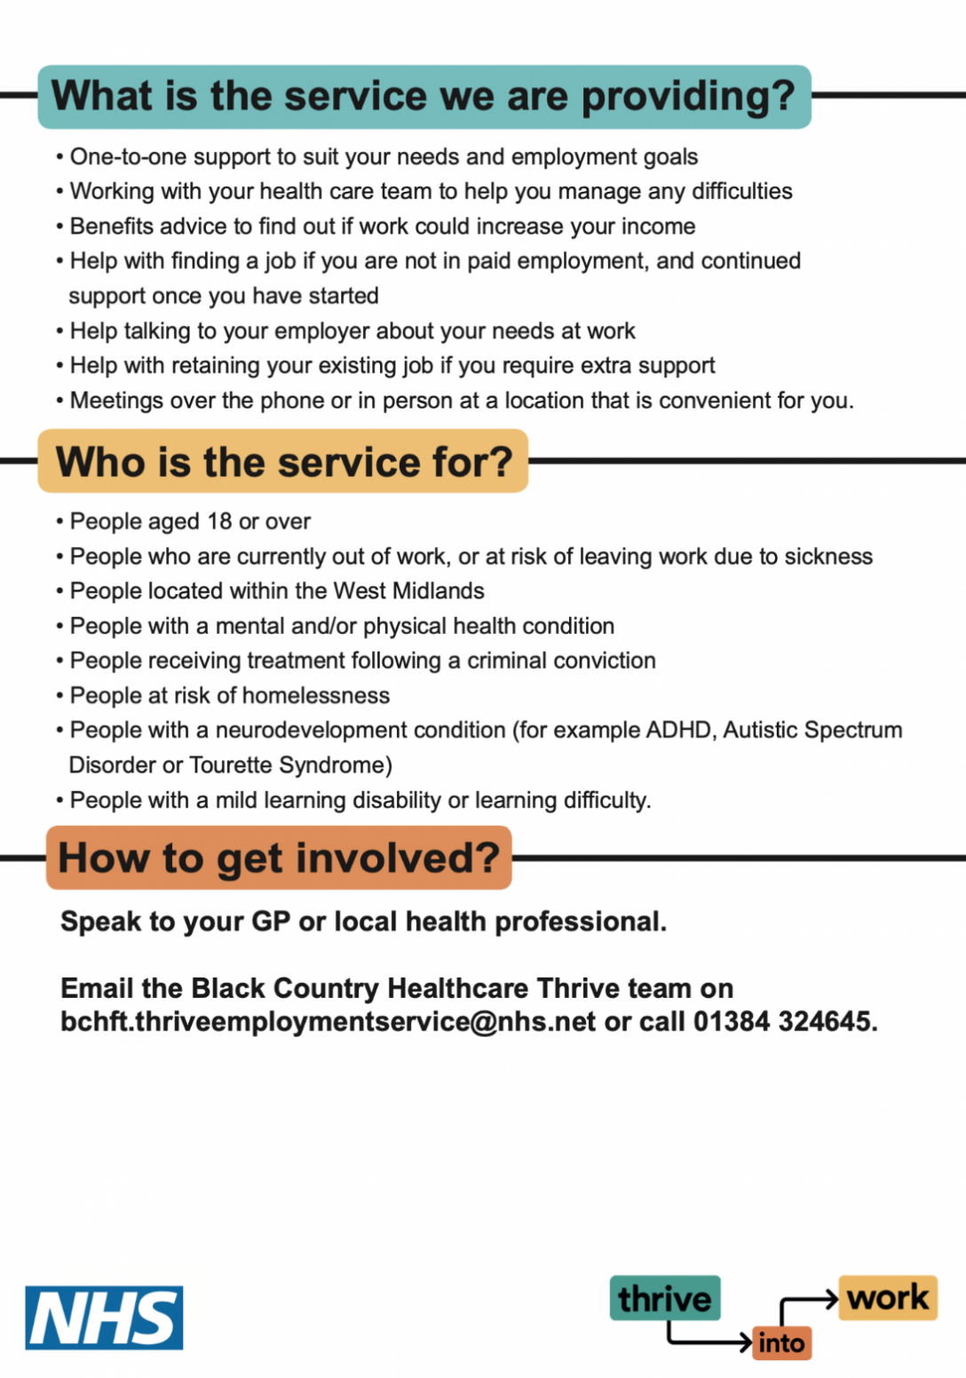

**Come and Join Us for**

**Free Activities including:**

Face Painting, Nail Painting, Arts & Crafts, Food & Drink

Information About Our Local Services

Health Checks