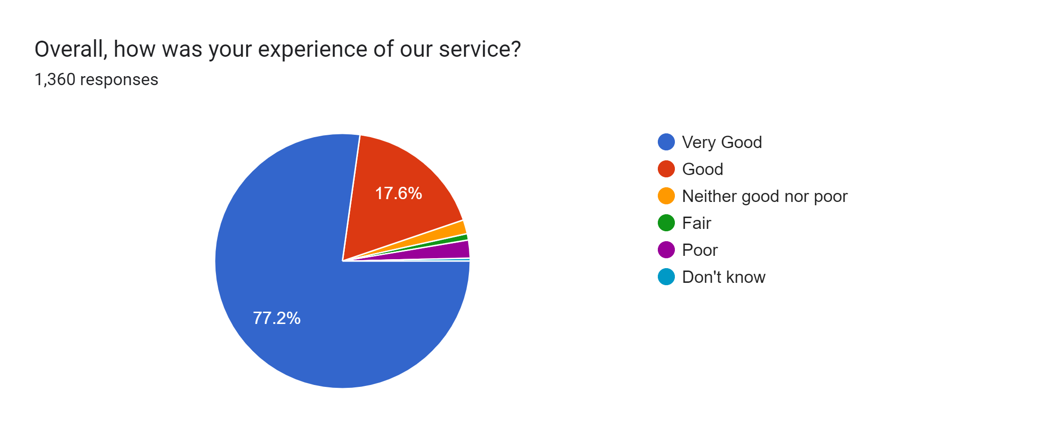**Friends and Family Chart January 2023**