Malmesbury Medical Partnership
Malmesbury Primary Care Centre

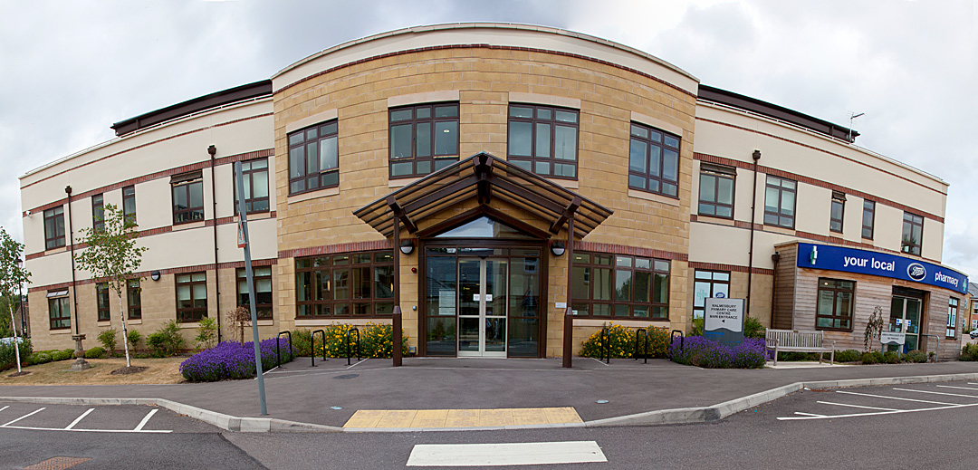

Statement of Purpose
Health and Social Care Act 2008

Part 1

Health and Social Care Act 2008, Regulation 12, schedule 3

The provider’s business contact details, including address for service of notices and other documents, in accordance with Sections 93 and 94 of the Health and Social Care Act 2008

1. Provider’s name and legal status
Full name¹ | Malmesbury Medical Partnership
CQC provider ID | 1-199751841
Legal status¹ | Partnership

2. Provider’s address, including for service of notices and other documents
Business address² | Malmesbury Primary Care Centre  Priory Way  Malmesbury  Wiltshire  SN16 0FB
Business telephone | 01666 825 825
Electronic mail (email)³ | david.grogan@nhs.net

We do wish to receive notices and other documents from CQC by email

3. The full names of all the Partners

John Gregory PETTIT

Jacqueline Suzanne NEALE

James HANSLIP

Thomas ESTCOURT

David Andrew GROGAN

Christopher PHILIPS

Laura HAYNES

Part 2

Aims and objectives

- To provide high quality primary care treatment to our patient population to include consultations, examinations and treatment of medical conditions.

- To focus on prevention of disease by promoting healthy living.

- To understand and meet the needs of our patients, involve them in decision making about their treatments and encourage them to participate fully.

- This practice will be ensuring everyone has easier and more convenient access to GP services, including appointments at evenings and weekends. We will be working with a variety of health care providers in several locations, all registered with CQC to provide GP services. The GP practice where the patient is seen will take responsibility for the regulated activity delivered there, regardless of where the patient is registered.

- To involve other professionals in the care of our patients where it is in the patients best interests; i.e. referring for specialist care and advice.

- To ensure that all members of the team have the right skills and training to carry out their duties competently.

- To create an educational environment, where staff promote and care learning amongst themselves and GP Registrars

- To review annually patient satisfactions surveys of the people who use our service and use the results to change when required.

Part 3
Location and the people who use the service their service type(s) and regulated activities.

Name of location | Malmesbury Primary Care Centre
Address | Priory Way  Malmesbury  Wiltshire
Postcode | SN16 0FB
Telephone | 01666 825825
Email | david.grogan@nhs.net

Description of the location

Malmesbury medical Partnership practice from a modern, purpose built, Primary Care Centre situated in the historic town of Malmesbury.

We serve a population of circa 15,750 from the town and surrounding communities.

CQC service user bands
The people that will use this location (‘The whole population’ means everyone).
The whole population

The CQC service types(s) provided at this location
Doctors consultation Service (DCS)
Doctors treatment Service (DTS)
Regulated activity(ies) carried on at this location
Treatment of disease, disorder or injury
Registered Manager for this activity: Dr John Pettit
Surgical Procedures
Registered Manager for this activity: Dr John Petitt
Diagnostic and Screening procedures
Registered Manager for this activity: Dr John Petitt
Maternity and Midwifery service
Registered Manager for this activity: Dr John Petitt
Family Planning Service
Registered Manager for this activity: Dr John Petitt

Part 4
Registered manager details

The information below is for manager number: | 1 | of a total of: | 1 | Managers working for the provider shown in part 1

1. Manager’s full name | Dr John Pettit

2. Manager’s contact details
Business address | Malmesbury Primary Care Centre  Priory Way  Malmesbury  Wiltshire  SN16 0FB
Business telephone | 01666 825825
Manager’s email address
John.pettit@nhs.net

3. Locations managed by the registered manager at 1 above
(Please see part 3 of this statement of purpose for full details of the location(s))
Name of location | Percentage of time spent at this location
Malmesbury Primary Care Centre |  | 100%
4. Regulated activities managed by this manager:
Treatment of disease, disorder or injury
Surgical procedures
Diagnostic and screening procedures
Maternity and midwifery services
Family planning service

5. Locations, regulated activities and job shares
Where this manager does not manage all of the regulated activities ticked / checked at 4 above at all of the locations listed at 3 above, please describe which regulated activities they manage at which locations below.
Please also describe below any job share arrangements that include or affect this manager.
N/A

